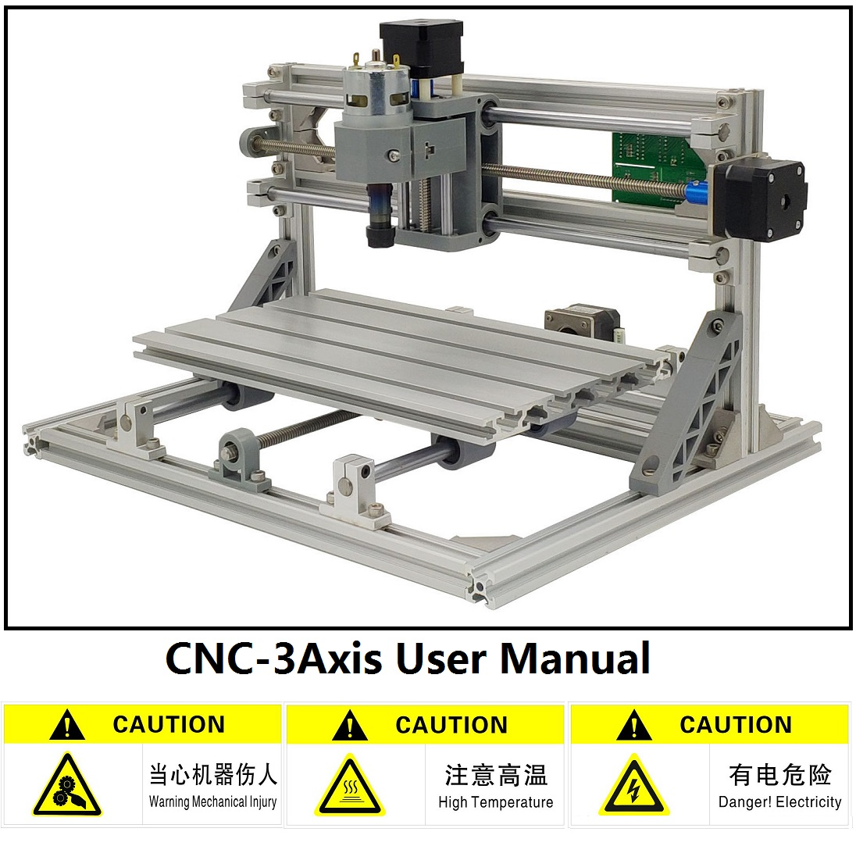

**Part B: User manual**

**Version .1.2**

**Control board description:**

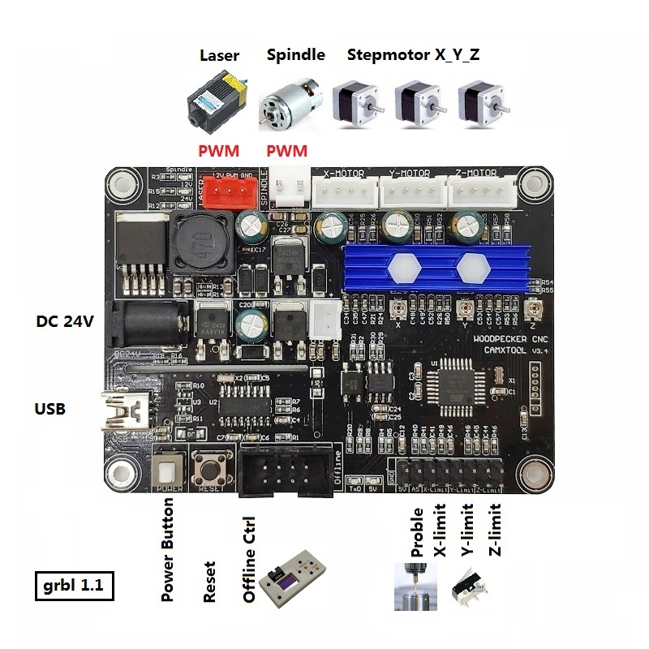

**Driver install: (** software --> Driver --> CH340SER.exe **)**

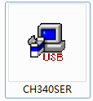

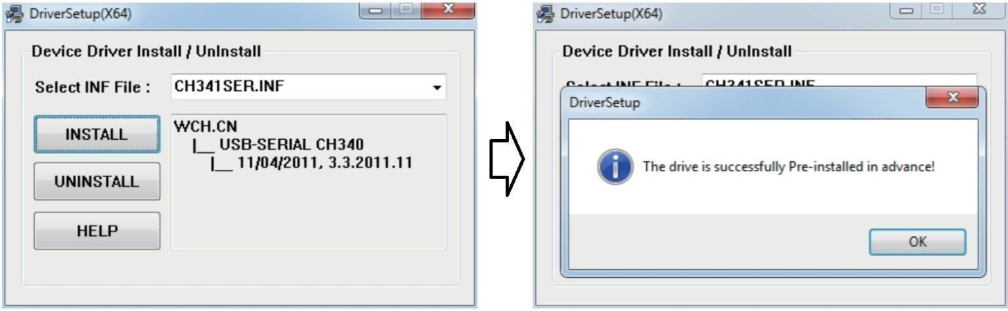

**Determine your Machine's COM port:**

* Windows XP: Right click on "*My Computer*", select "*Properties*", select "*Device Manager*".
* Windows 7: Click "Start" -> Right click "*Computer*" -> Select "*Device Manager*" -> "*Ports (COM & LPT)*"
* Your machine will be the USB Serial Port (COMX), where the “X” represents the COM number, for example COM5.
* If there are multiple USB serial ports, right click each one and check the manufacturer, the machine will be "*CH340*".

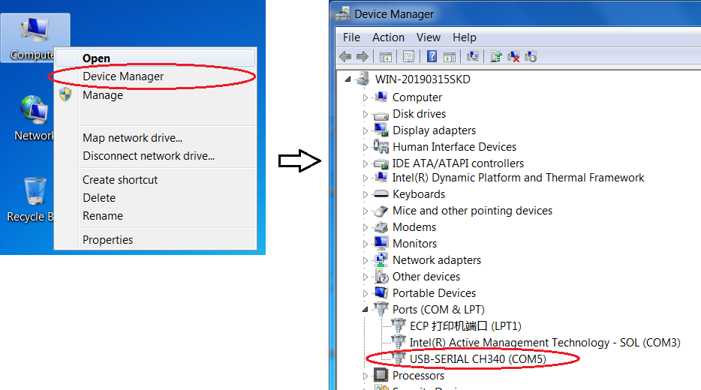

**Mode-3Axis-A:(Machining with spindle) & Control with PC**

**- Use the Usb cable for connecting computers.(** **Don't plug in the offline controller!)**

**- Open grblControl software(**software -> Grblcontrol ->grblControl.exe**)**

**Notice: 1. The 3-Axis NC files need users to design by themselves using CAM software.**

**2. The grblControl just send the NC file to machine.**

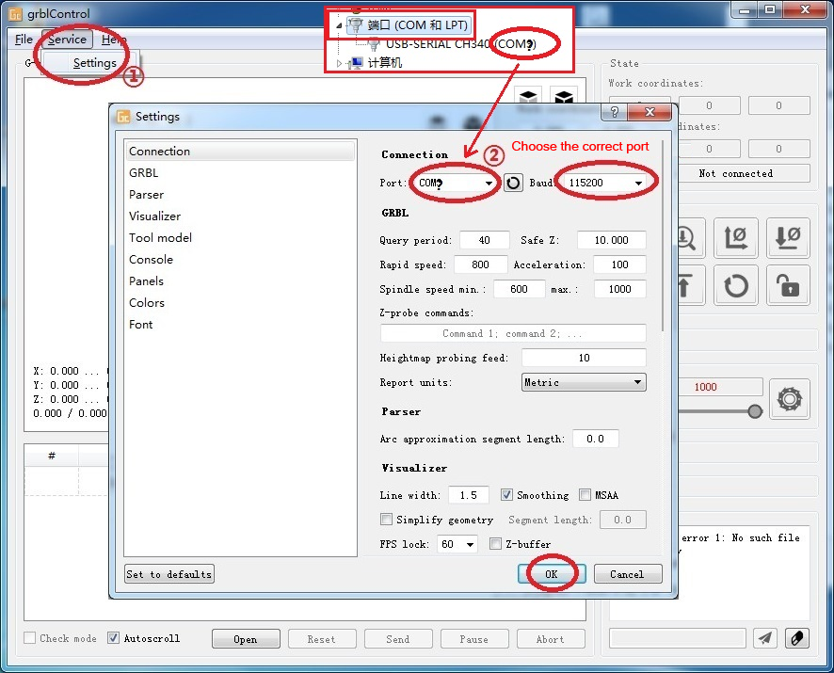

* Console window print ” [CTRL+X] < Grbl 1.1f ['$' for help]” If the connection is successful.
* Console window print ” Serial port error 1: No such file or directory “ indicate that the connection is failed.

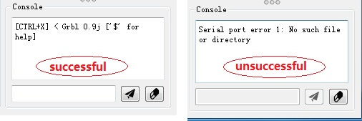

* Grblcontrol Use

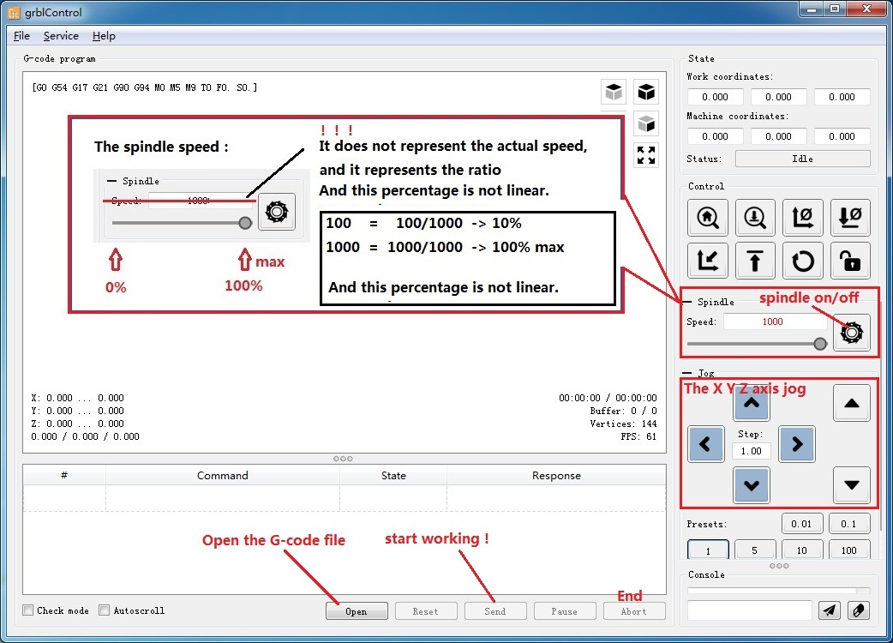

* Tool setting

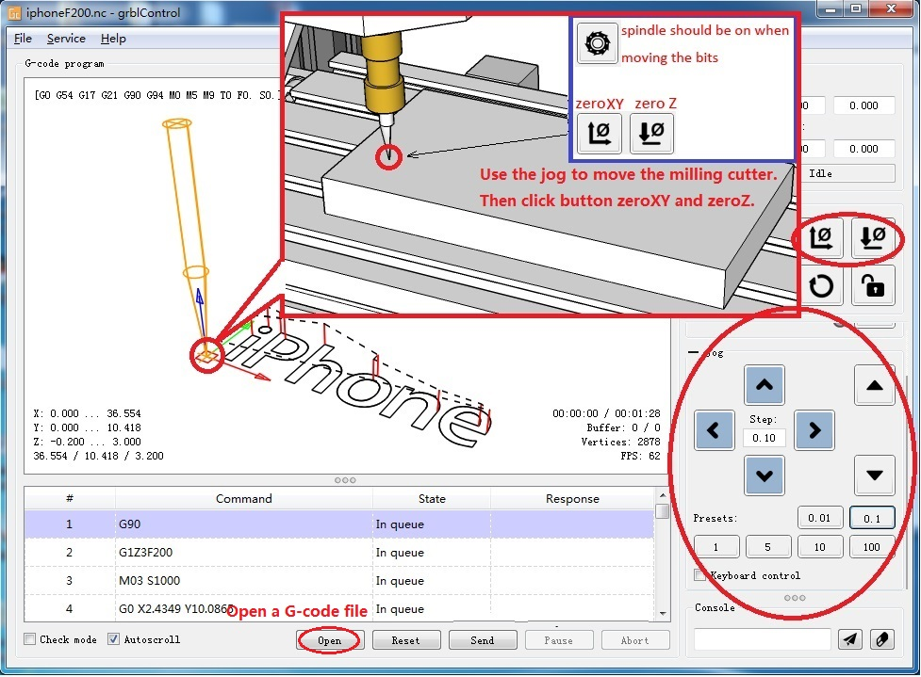

**Mode-3Axis-B:(Machining with spindle) & Control with Offline Controller**

**- Connecting the Offline Controller to PC with the USB cable.**

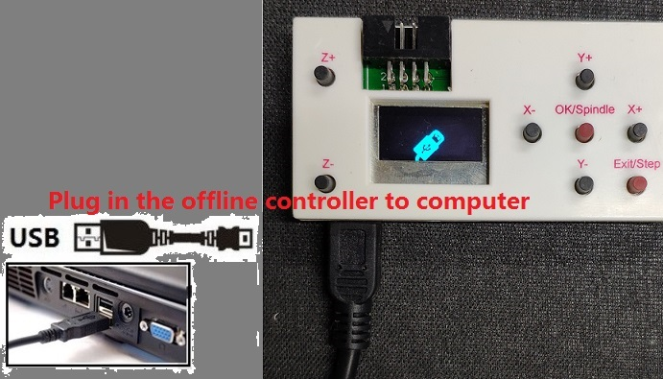

**- Then. Save the “3-Axis NC” flie to Offline Controller.**

**- Refer to the ”Offline Controller User Manual” to work begin.**

**Notice: The 3-Axis NC files need users to design by themselves using CAM software.**

**Mode-2Axis-A:(Machining with Laser) & Control with PC**

**- Use the Usb cable for connecting computers.(** **Don't plug in the offline controller!)**

**- Open LaserGRBL software(**laser -> laserGRBL**) and install.**

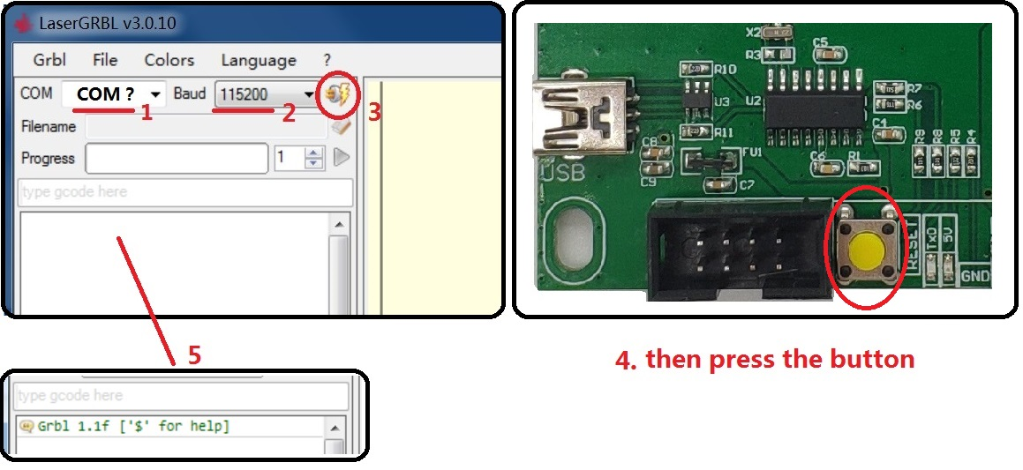

* Console window print ” Grbl 1.1f ['$' for help]” If the connection is successful.
* If the port selection is wrong, no information will be returned.

**- Focusing**

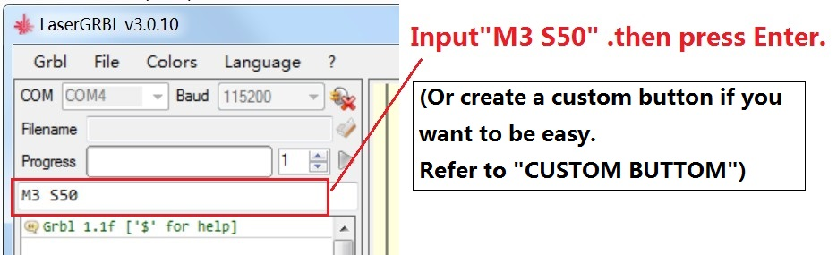

**The laser will be turned on with low power model. Then Rotate the lens to minimize the spot.**

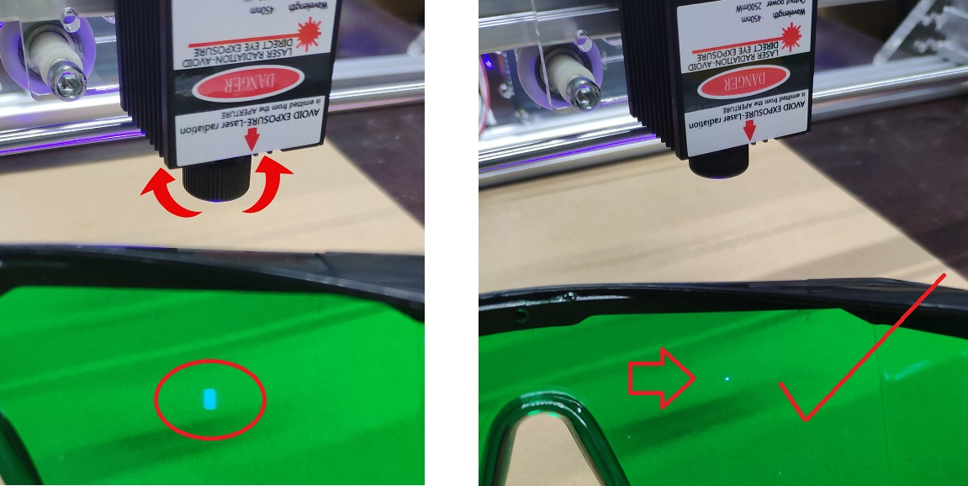

**- RASTER IMAGE IMPORT**

Raster import allows you to load an image of any kind in LaserGRBL and turn it GCode instructions without the need of other software. LaserGRBL supports photos, clip art, pencil drawings, logos, icons and try to do the best with any kind of image.

It can be recalled from “File, Open File” menu by selecting an image of type jpg, png or bmp.

**[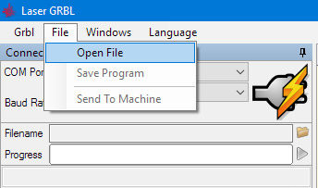](http://lasergrbl.com/wp-content/uploads/2017/03/openfile-e1488792747167.jpg)**

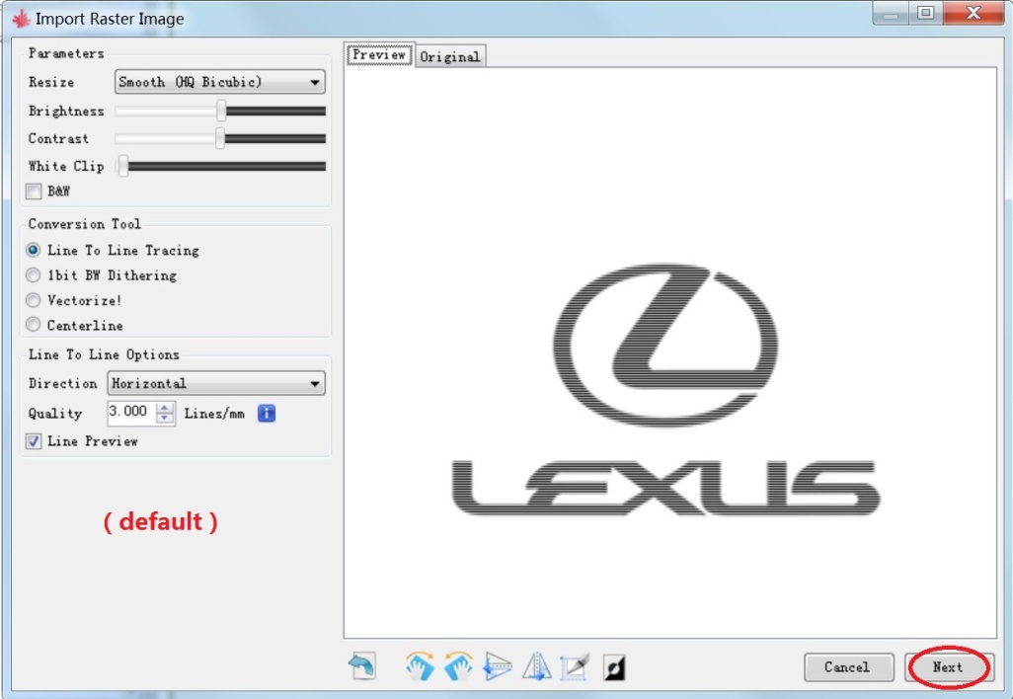

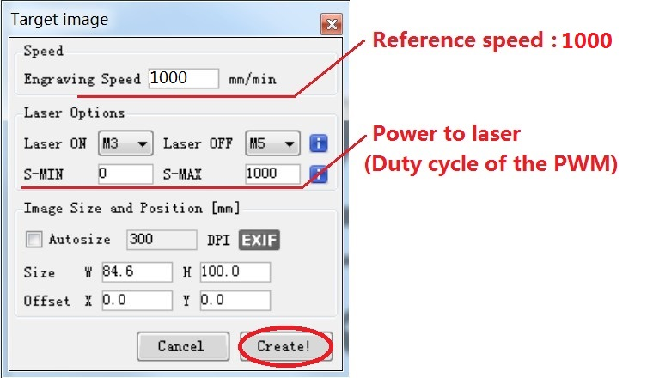

**Notice: speed and S value are different with material.**

**- Click this button to begin if use the computer control.**

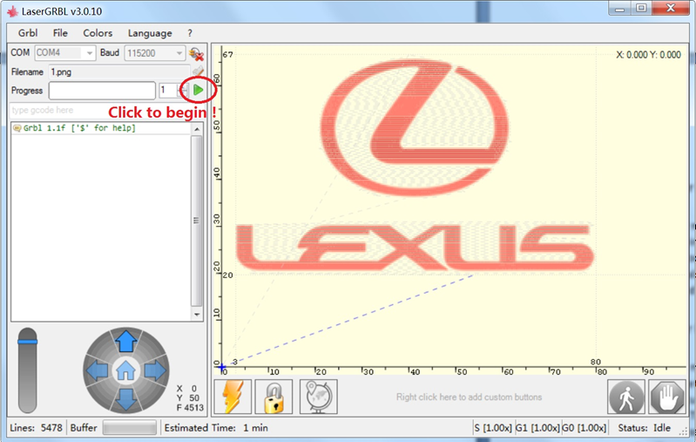

**- Save program to “NC” file if use the offline controller.**

**(Mode-2Axis-B: (Machining with Laser) & Control with Offline Controller)**

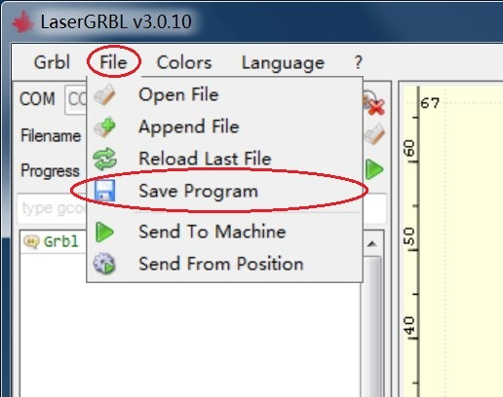 

**- Offline controller can be used as card reader through USB cable.**

**- Then Plug in the offline controller to control board. (Don’t plug in the USB cable to computer)**

**- Then. Refer to the ”Offline Controller User Manual” to work begin.**

**EXPERT MODE**

* **Expert mode lets users have more control over the machine. But Users should have some professional knowledge**

1. **Custom button in the laserGRBL software.**

LaserGRBL support custom buttons. Right-click in button area to add a new custom button.

[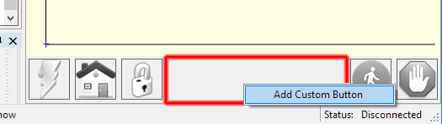](http://lasergrbl.com/wp-content/uploads/2017/03/addcustom.jpg)Add custom button

In custom button you can write a set of G-Code instruction to execute customized actions.

There is 3 types of custom buttons:

* Button
* TwoStateButton
* PushButton

Custom button of type “Button” contains a block of GCode to be executed on click. This could be used to launch a series of gcode instruction i.e. for trace a frame around an image or set a new zero position.

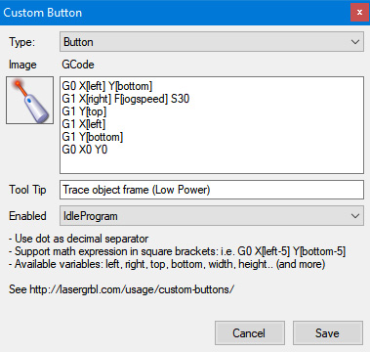

“TwoStateButton” contains two block of GCode. The first action is executed on a first click, then the second action is executed on a second click. This is very useful for action like toggling laser on-off to see its position

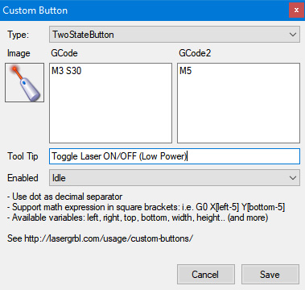

Toggle laser ON/OFF

“PushButton” is similar to “TwoStateButton” but the first action is executed on mouse down, the second is executed on mouse up.

Custom Buttons support a series of variables that can be used in expressions. Here is the full set of supported variables:

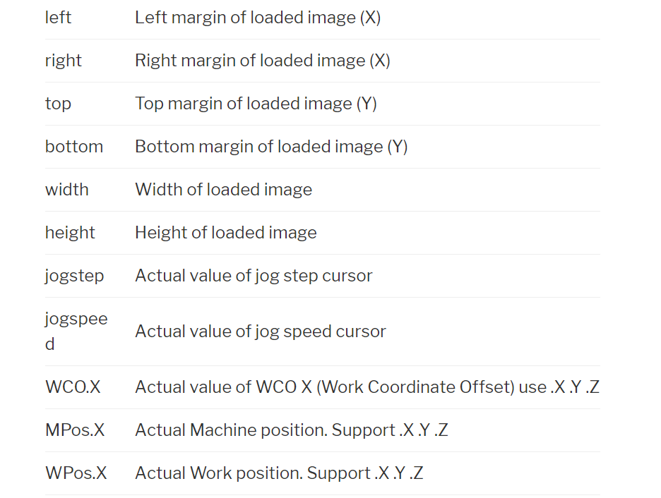

**2. Default configuration**

